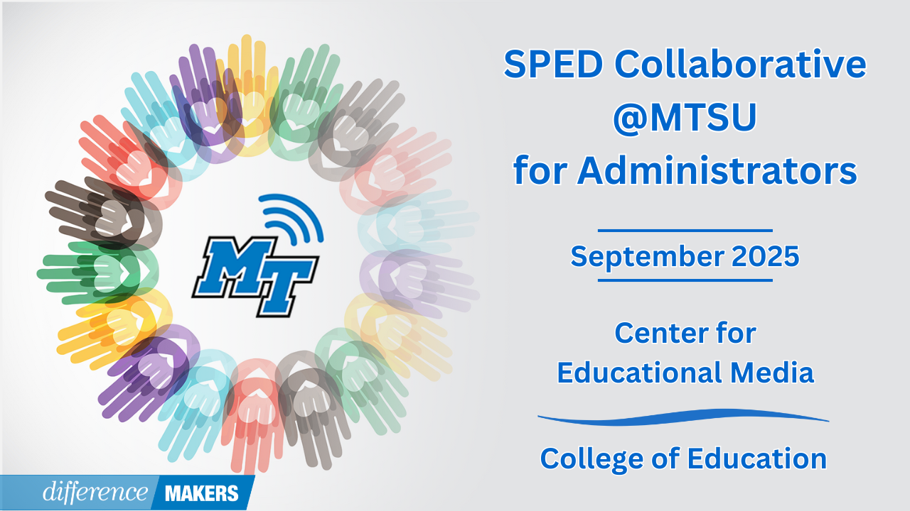
SPED Collaborative @MTSU for Administrators
Onsite Conference
September 26, 2025

8:30am- 8:45am Welcome/Introductions
- Jenny Marsh, Manager, CEM Professional Development Center, MTSU
- Dr. Laura Clark, Director, Center for Educational Media, MTSU
- Dr. Neporcha Cone, Dean College of Education, MTSU
8:45am-10:00am (Session 1) Working Together for Impact: The Administrative Team's Role in Special Education Success
- Dr. Charles Farmer, Principal, Freedom Middle School, Franklin Special District
- Dr. Lauren Bauer, Assistant Principal, Freedom Middle School, Franklin Special District
- Adam Demonbreun, Asst Principal/Athletics Director, Freedom Middle School, Franklin Special District
10:00am-10:15am Break

10:15am-11:30am (Session 2) Working Together for Impact: The Administrative Team's Role in Special Education Success
- Dr. Charles Farmer, Principal, Freedom Middle School, Franklin Special District
- Dr. Lauren Bauer, Assistant Principal, Freedom Middle School, Franklin Special District
- Adam Demonbreun, Asst Principal/Athletics Director, Freedom Middle School, Franklin Special District
- Q&A Facilitated by Dr. Laura Clark
11:30am-12:45pm Networking Lunch

SPED Collaborative @MTSU for Administrators
Onsite Conference
September 26, 2025

12:45-12:50pm Afternoon Welcome/ Back in Seats

12:50-2:05pm (Session 3) The Building Leader’s Role as the Special Education LEA Representative
- Susan Usery, Senior Director of Special Education Programs, TDOE
- Tate Ball, Associate Counsel for Special Education, TDOE
- Q&A Facilitated by Dr. Laura Clark

2:05pm-2:20pm Break

2:20pm-3:35pm (Session 4) Support Your Teachers: Effects of a Rigorous and Supportive Coaching Cycle
- Joshua Reese, Ed.S., Special Education Supervisor, Loudon County Schools
- Jessica Williams, Ed.S., Special Education Supervisor, Loudon County Schools
- Q&A Facilitated by Dr. Laura Clark
3:35pm-3:45 Close/Certificates
- Dr. Laura Clark, Director, Center for Educational Media, MTSU

