Name of Your School

Public School
Suicide Behavior Procedure and Checklist

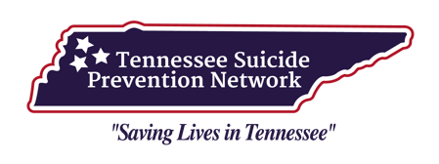

Suicide Behavior Procedure

When any staff member identifies a student with suicidal ideation, making suicidal statements, writing suicidal notes, and/or exhibiting self-harm such as cutting or any similar at risk behaviors, the staff member will notify a school counselor, administrator, psychologist, or school designated contact immediately. The staff member (or another adult staff member) must stay with the student until the designated individual arrives. The student should not be left alone at any point.
*If the student is in the midst of an attempt (i.e., has informed a staff member that he/she has just taken a handful of pills), follow the above procedure and contact medical emergency services immediately. School designated contact, or school designee, should be identified in each school as soon as possible.

Confidentiality
Staff members are not permitted to promise confidentiality or honor a previous promise of confidentiality if the student might harm himself/herself. Staff members must explain to the student that information may be shared with others in order to help him/her, but there will not be discussion with others who do not need to know of the incident. (Staff members should explain that any time someone is potentially a danger to himself/herself or others, it must be reported.)

The following steps should be completed by school’s counselor/administrator/psychologist/school designee (see Checklist):

- Counselor/administrator/psychologist/school designee addresses the situation immediately by bringing the student to his/her office to discuss concern for the student’s safety.

- The student is not to be left alone at any point (i.e., escort to restroom, water fountain, locker, etc.).

- The counselor/administrator/psychologist/school designee should consult the principal or other school official to determine a course of action. If the risk level warrants, your local Mobile Crisis should be contacted and informed of the situation (see CSSRS Triage Protocol). Remember: DO NOT LEAVE THE STUDENT ALONE.

- In middle and high schools, the school resource officer (SRO)/law enforcement should be notified for the safety of student and staff if deemed necessary (i.e., standing by in case of flight risk and/or aggression/non-compliance on the part of the student). School administrators, principal or assistant principal, should be contacted and made of situation and steps moving forward.

- The counselor/administrator/psychologist/school designee should call the student’s parent/guardian as soon as possible after a student has been identified as being at risk for suicide and ask him/her/them to come to the school for a meeting.

- Inform the parent/guardian that the student MUST leave with a parent, guardian, or family member. If a parent cannot be reached, the school counselor/administrator/psychologist/school designee should access all other emergency contacts in an attempt to locate them (maintain confidentiality).
- If parent/guardian cannot be reached, the counselor/psychologist/school designee should consult the principal to determine the next step. It may be necessary to contact the Department of Children’s Services (DCS), School Resource Officer, or local law enforcement. School officials may also want to consult with any of the following individuals:

Central Office Main Number: 931-388-8403 (Example from pilot School System)
- Robb Killen, Supervisor of Counseling & Mental Health (ext. 8169 or 931-981-3038 mobile)
- Laurie Stanton, Coordinated School Health Coordinator (ext.8145)
- Ron Woodard, Director of Pupil Services (ext. 8101)
- Lisa Ventura, Supervisor of Special Education (ext.8112)
- Ryan Longnecker, Supervisor of Secondary Instruction (ext.8153)
- Sonya Cathey, Elementary Lead Principal (ext.4010)
- Debbie Robinson, Youth Villages Mobile Crisis Regional Supervisor (615-852-9056 mobile)
- Tasha Dayhoff, Youth Villages Mobile Crisis Supervisor (731-426-4824)

- After parent/guardian contacted and arrived at the school, school officials will meet and explain the events leading up to the child’s suicidal behavior. This meeting will serve as the basis for school officials and parents to have a conversation about the next steps for the child’s safety. School districts do not have the ability to diagnose and determine what the mental health status of the child may be or what services may be best for the child outside of the school setting. If parents request resource contacts, be sure to provide more than one possible resource (refer to local community health centers).

- If the parent/guardian does not commit to seeking assistance for the child, it may be appropriate for the school officials to notify DCS, School Resource Officer, or local law enforcement regarding the concern for the child’s safety. If the school official will be communicating any information about the child to an agency other than DCS or law enforcement, a Consent to Contact Form must be completed prior to the call. If a Release of Information Form cannot be completed at that time, parent permission must still be obtained prior to sharing information with agencies that are not DCS or law enforcement, and the form can be completed after the crisis has passed.

- The student must leave school with a parent/guardian, or with DCS or law enforcement officials. (He/She should not be allowed to leave school property without appropriate supervision, e.g. riding the bus.)

- The counselor/administrator/psychologist/school designee should document the incident with the following information: actions taken, the parent notification and response, and follow-up efforts taken by the counselor/administrator/psychologist/school designee.

- The counselor/administrator/psychologist/school designee should be encouraged to meet with the child on the first day back to school following the behavior to monitor the child’s well-being, safety, and assure that the student is receiving the appropriate support. The parent/guardian should be asked to participate in that meeting.

- In the event the student leaves the school on his/her own without authorization, the counselor/administrator/psychologist/school designee should contact law enforcement informing them that a child at risk for suicide has run away from school and may be a risk to self or others.

Note: All use of this Suicide Behavior Procedure Checklist must include recognition of the Tennessee Suicide Prevention Network (TSPN) and this source document. However, alterations are encouraged for catering to area school districts and schools with recognition of this document and TSPN.

Suicide Behavior Checklist

- Contact the School Counselor/Administrator/Psychologist/School Designee
Take all threats seriously
Contact counselor/administrator/psychologist/school designee immediately
Do not leave student alone

- Identification of Risk (Form A: Identification of Risk)
Completed by individual of initial contact with student

- Administer Suicidal Screening (Form B1: C-SSRS Screener with Triage Points)
(Form B2: C-SSRS Risk Assessment, intended for use by school counselors, psychologists, or other clinicians)
Interview student to gather information regarding student's ideation, risk factors, and protective factors.

- Determine Risk Level on C-SSRS Screener and Take Appropriate Action

- Contact Mobile Crisis, if needed (1-866-791-9222) Utilize local number

- Issues of Abuse and Neglect
If a student indicates that parental abuse or neglect is the reason for contemplating suicide, parent/guardian contact should not be made. Instead, immediately inform the principal and follow protocol for calling DCS. When notifying DCS, it must be emphasized that immediate action is necessary to protect the child from harm. Contact Mobile Crisis, if needed (1-866-791-9222) utilizing local number.

- Parent Contact (Form C: Notification of Suicidal Thoughts or Feelings)
- Explain the reason for the phone call and explain that the parent/guardian must come to the school immediately to address safety issues with their child.
- If the parent/guardian is unable to be reached by phone, and could possibly be at home, contact the school resource officer to make a home notification.
- If a parent/guardian refuses to get help for the student, please report to DCS. *Document if parent/guardian refuses to come to school

- Meeting with Parent (Form D: Acknowledgement of Notification)
(Form E: Suicide Warning Signs)
(Form F: Consent to Contact)
- Meet with parent/guardian and discuss threats and seriousness of the situation.
- Have parent/guardian provide input on circumstances that might relate to the issues addressed
- Have parent/guardian sign the Acknowledgement of Notification form. (Keep original and give a copy to the parents) Provide a copy of Suicide Warning Signs.

- Explain the school’s response and the need for the immediate follow up (depending on risk level) by a mental health professional or physician. If parents request resource contacts, be sure to provide at least three possible resources. If they desire to connect with one specific resource, you may offer to help them set up an appointment.
- A Consent to Contact form may be filled out in order for the school to communicate with the professional(s) who will assess the child.

- Safety Plan (Form G: Safety Plan)
(Form H: Suicide-Proofing Your Home)
The importance of restricting access to means of suicide and general safety planning should be stressed to the parent/guardian. Provide a copy of Suicide-Proofing Your Home. Provide contact for local Mobile Crisis, (1-866-791-9222), utilizing local number.

- Urgent Care/Behavioral Health Feedback
If child does not meet criteria for hospitalization based on findings from behavioral health professionals (Mobile Crisis), interventions, and recommendations may be provided to the school (i.e., acknowledgement that student will attend school the next day).

- Student Departure from School
Child may only leave school in the company of parent/guardian, DCS, or law enforcement. In the event the student leaves the school on his/her own without authorization, contact law enforcement informing them that a child at risk for suicide has run away from school and may be a risk to self or others.

- Plan for student return (Form I: Release of Information to Faculty/Staff)
Parent/guardian may provide information on current condition and sign a Release of Information to Faculty/Staff (on a need-to-know basis).
- Assign a staff member/counselor/psychologist/school designee to liaison with student, staff and parent/guardian to focus on the child’s safety. This person:
  - Maintains confidentiality.
  - Handles discussion of the case with school personnel on a need-to-know basis.
  - Work with classroom teachers on student's academic needs.
  - Meets with staff to discuss procedures for reentry if needed.
  - Helps student with readmission and serves as contact for other staff members.
  - Reviews files to understand what precipitated the suicide ideation and what might precipitate another crisis.
  - Keeps all documentation from this checklist in a safe and secure location.

- Student return (Form J: Follow-Up Meeting)
Incorporate engagement with families with the school and the student’s behavioral health needs to provide a safe environment for the child upon their return. Schedule follow-up meeting with student and parent/guardian within one week of return.

Form A
Identification of Risk

Date student was identified at risk: __________________________
Name of School: _______________________________
Name of Student: _______________________________
Date of Birth of Student: ___________________________
Grade: ______________________
Name of Parent/Guardian: _____________________ Telephone Number: ____________________

Who identified Student as being at risk:____________________________
- Staff
- Teacher
- Support Staff
- Student/Friend
- Other: ___________________
- Others present: _________________________
Reason for concern (verbal threat/actions, etc.):
________________________________________________________________________________________________________________________________________________________________________________________________________________________________________________________________________________________________________________________________________________

Form B1
C-SSRS SCREENER WITH TRIAGE POINTS
Administered by Trained Faculty/Staff/School Designee that have completed online training:
https://www.practiceinnovations.org/portals/0/CSSRS/shell.html

- SUICIDE IDEATION DEFINITIONS AND PROMPTS: | Past  month
Ask questions that are in bolded and underlined | Yes | No
Ask Questions 1 and 2
1) Wish to be Dead:
Person endorses thoughts about a wish to be dead or not alive anymore, or wish to fall asleep and not wake up?
Have you wished you were dead or wished you could go to sleep and not wake up?
2) Suicidal Thoughts:
General non-specific thoughts of wanting to end one’s life/commit suicide, “I’ve thought about killing myself” without general thoughts of ways to kill oneself/associated methods, intent, or plan.
Have you actually had any thoughts of killing yourself?
If YES to 2, ask questions 3, 4, 5, and 6. If NO to 2, go directly to question 6
3) Suicidal Thoughts with Method (without Specific Plan or Intent to Act):
Person endorses thoughts of suicide and has thought of a least one method during the assessment period. This is different than a specific plan with time, place or method details worked out. “I thought about taking an overdose but I never made a specific plan as to when where or how I would actually do it….and I would never go through with it.”
Have you been thinking about how you might do this?
4) Suicidal Intent (without Specific Plan):
Active suicidal thoughts of killing oneself and patient reports having some intent to act on such thoughts, as oppose to “I have the thoughts but I definitely will not do anything about them.”
Have you had these thoughts and had some intention of acting on them?
5) Suicide Intent with Specific Plan:
Thoughts of killing oneself with details of plan fully or partially worked out and person has some intent to carry it out.
Have you started to work out or worked out the details of how to kill yourself? Do you intend to carry out this plan?
6) Suicide Behavior Question:
Have you ever done anything, started to do anything, or prepared to do anything to end your life?
Examples: Collected pills, obtained a gun, gave away valuables, wrote a will or suicide note, took out pills but didn’t swallow any, held a gun but changed your mind or it was grabbed from your hand, went to the roof but didn’t jump; or actually took pills, tried to shoot yourself, cut yourself, tried to hang yourself, etc.

If YES, ask: How long ago did you do any of these?
- Over a year ago?
- Between three months and a year ago?
- Within the last three months?
- Within the last week?

II. Triage Protocol for C-SSRS Screening

(Items 1-5: Please take suggested action which is linked to the last question answered with a ‘YES’)
Items 1 – 5 Contact parents
Item 3+5 – Contact parents, then Mobile Crisis

(If ‘YES’ on item 6, then take suggested action related to timeframe of suicide behavior)
Item 6 – If over a year ago: Contact parents
If between 3 months and 1 year ago: Contact parents
If within last 3 months: Contact parents, then Mobile Crisis
If within the last week: Contact parents, then Mobile Crisis

*Adapted from: http://www.cssrs.columbia.edu/

Form B2
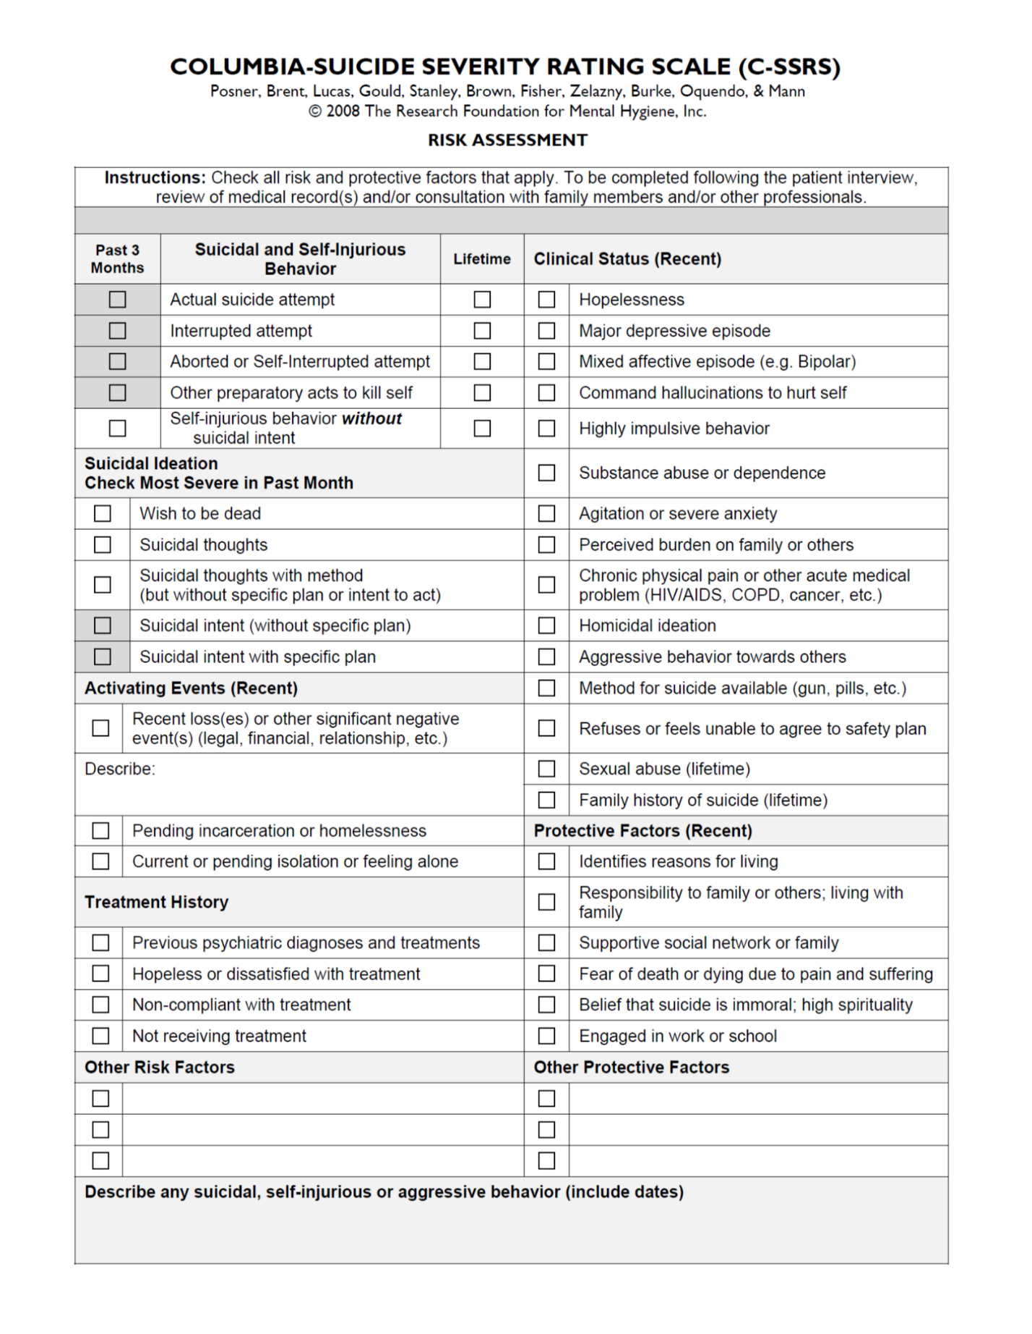
(NOTE: This form should be used only by a school psychologist, counselor, or other clinician.)

Form C
NOTIFICATION OF SUICIDAL THOUGHTS OR FEELINGS

Student’s Name: ________________________________ Date of Contact: ____________
Parent/Guardian Name: ________________________ Time of Contact: ____________
School Team Member: ___________________________ School: ____________________
(i.e., School Psychologist, Social Worker, School Counselor, School Designee, etc.)
When contacting the student’s parent or guardian:
- Provide your name and position in the school
- Assure the parent/guardian that the student is currently safe
- State that in your professional judgment depending on the results of the C-SSRS screening and assessment
- Provide names of community counseling resources, if appropriate
- If appropriate, offer to facilitate the referral or contact child’s therapist (mention the Consent to Contact form if appropriate)
- Determine the parent’s intent to seek appropriate services for the student depending on screening and assessment results
Parent/Guardian Response: ______________________________________________________________________________________________________________________________________________________________________________________________________________________________________________________________________________________________________________________________________________________________________________________________________
Any Required Follow-Up:

Form D
ACKNOWLEDGMENT OF NOTIFICATION
I/We _______________________________, the parents/guardians of _____________________________, have had a conference with school personnel (name) ________________________________ on ________________________ (date).
I/We have been notified that our child is experiencing suicidal thoughts and may be in danger of harming himself/herself. I/We have been advised that we should immediately seek consultation from a community-based mental health professional. Mental health resources could be provided by school staff, if requested.
If I/we opt for supportive interventions outside the professional mental health arena, such as religious-based interventions, I/we will provide at a minimum a safety plan and an issues-based intervention procedure that will keep the child safe and address the precipitant issues. If I/we choose interventions other than a mental health professional (such as religious-based interventions) I/we will inform school personnel of the outcome, including any safety plan.
Agree to sign as Parent Refuse to sign as Parent
I/We have been given the “Suicide-Proofing Your Home” brochure from the Tennessee Suicide Prevention Network.
A follow-up conference with school personnel has been scheduled for: ____________________.

_________________________________ ____________________________________
(Parent/Guardian) (School Personnel/Witness Name and Title)

_________________________________ ____________________________________
(Parent /Guardian) (School Personnel/Witness Name and Title)

Note: This form will be maintained in a file separate from the student’s educational record for a period to include the balance of the current year as well as the entire following school year.

Form E
SUICIDE WARNING SIGNS
There is no typical suicide victim. No age group, ethnicity, or background is immune. Fortunately, many troubled individuals display behaviors deliberately or inadvertently signal their suicidal intent. Recognizing the warning signs and learning what to do next may help save a life.

The Warning Signs:
The following behavioral patterns may indicate possible risk for suicide and should be watched closely. If they appear numerous or severe, seek professional help at once. The National Suicide Prevention Lifeline at 1-800-273-TALK (8255) provides access to trained telephone counselors, 24 hours a day, 7 days a week or the Crisis Text Line by texting TN to 741 741.
- Talking about suicide, death, and/or no reason to live
- Preoccupation with death and dying
- Withdrawal from friends and/or social activities
- Experience of a recent severe loss (especially a relationship) or the threat of a significant loss
- Experience or fear of a situation of humiliation of failure
- Drastic changes in behavior (i.e., sudden aggression, anger, or apathy)
- Loss of interest in hobbies, work, school, etc.
- Preparation for death by making out a will (unexpectedly) and final arrangements
- Giving away prized possessions
- Previous history of suicide attempts, as well as violence and/or hostility
- Unnecessary risks; reckless behavior
- Loss of interest in personal appearance
- Increased use of alcohol and/or drugs
- General hopelessness
- Recent experience humiliation or failure
- Unwillingness to connect with potential helpers

Feelings, Thoughts, and Behaviors
Nearly everyone at some time in his or her life thinks about suicide. Most everyone decides to live because they come to realize that the crisis is temporary, but death in not. On the other hand, people in the midst of a crisis often perceive their dilemma as inescapable and feel an utter loss of control. Frequently, they:
- Can’t stop the pain
- Can’t think clearly
- Can’t make decisions
- Can’t see any way out
- Can’t sleep eat or work
- Can’t get out of the depression
- Can’t make the sadness go away
- Can’t see the possibility of change
- Can’t see themselves as worthwhile
- Can’t get someone’s attention
- Can’t seem to get control

What Do You Do?
- Be aware. Learn the warning signs listed on the first page.
- Get involved. Become available. Show interest and support.
- Ask if s/he is thinking about suicide.
- Be direct. Talk openly and freely about suicide.
- Be willing to listen. Allow for expressions of feelings and accept those feelings.
- Be non-judgmental. Avoid debating whether suicide is right or wrong, whether someone’s feelings are good or bad, or on the value of life.
- Avoid taunting the person or daring him/her to “do it”.
- Avoid giving advice by making decisions for someone else to tell them to behave differently.
- Avoid asking “why.” This only encourages defensiveness.
- Offer empathy, not sympathy.
- Avoid acting shocked. This creates distance.
- Don’t keep someone else’s suicidal thoughts (or your own) a secret. Get help, silence can be deadly.
- Offer hope that alternatives are available. Avoid offering easy reassurance; it only proves you don’t understand.
- Take action. Remove anything that the person could use to hurt themselves means. Get help from individuals or agencies specializing in crisis intervention and suicide prevention.
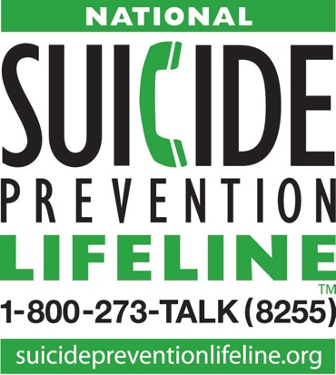
Who Can You Talk To?
- A community mental health agency
- A private therapist
- A school counselor or psychologist
- A family physician
- A suicide prevention/crisis intervention center
- A religious/spiritual leader

If you or someone you know is severely depressed or actively suicidal, call the National Suicide Prevention Lifeline at 1-800-237-TALK (8255). Trained counselors in your area are standing by to provide you with the help you need.
*Retrieved from: http://tspn.org/warning-signs
Form F
Consent to Contact
I, ______________________________________________, hereby give my consent for
(Printed Name of Parent/Guardian)
Name of the school ____________________________
_______to consult with and/or release records regarding my child to:
_______to request and/or receive information regarding my child from:

____________________________________________ ________________________
(Agency Name) (Phone Number)
____________________________________________ ________________________
(Agency Address) (Contact Person and Position)
____________________________________________ _____________________
(City, State, Zip Code) (Additional Information)

Child’s Name: __________________________________________________________
Date of Birth: __________________________________________________________
School of Attendance: __________________________________________________________
This information may be released/exchanged for the following purpose:
____________________________________________________________________________________________________________________________________________________________

________________________________________________ __________________
(Parent/Guardian Signature) (Date)

Form G
SAFETY PLAN (School Setting, examples below)

Step 1: Warning signs (each child will have individual signs that reflect their ideation):
1. Draws pictures____________________________________________________________________________
2. Withdraws from activities and doesn’t complete assignments_______________________________________
3. Unkempt appearance_______________________________________________________________________
Step 2: Internal coping strategies – Things I can do to take my mind off my problems without contacting another person:
1. Journal, write down your thoughts__________________________________________________________
2. Ignore off task behaviors__________________________________________________________________
3. ______________________________________________________________________________________
Step 3: People and social settings that provide distraction (student will identify locations/people that will reduce their stress):
- Name ____________________________Phone__________________________________
- Name ____________________________Phone__________________________________
- Place: Guidance Office______________________________________________________
- Place ___________________________________________________________________
Step 4: People whom I can ask for help:
- Name: School Counselor___________________________ Phone ___________________________________
- Name: Teacher (Favorite Teacher)____________________Phone ___________________________________
- Name: __________________________________________Phone ___________________________________
Step 5: Professionals or agencies I can contact during a crisis after school:
- Clinician Name: Other Mental Health Professional in the School Phone ______________________________
Clinician Pager or Emergency Contact #______________________________________________________
- Clinician Name ______________________________________Phone______________________________
Clinician Pager or Emergency Contact # ______________________________________________________
- Suicide Prevention Lifeline: 1-800-273-TALK (8255); Crisis Text Line: Text TN to 741741
- Local Emergency Service __________________________________________________________________
Emergency Services Address________________________________________________________________
Emergency Services Phone _________________________________________________________________
Making the environment safe:
1. _______________________________________________________________________________________
2. _______________________________________________________________________________________
From Stanley, B. & Brown, G.K. (2011). Safety planning intervention: A brief intervention to mitigate suicide risk. Cognitive and Behavioral Practice. 19, 256–264

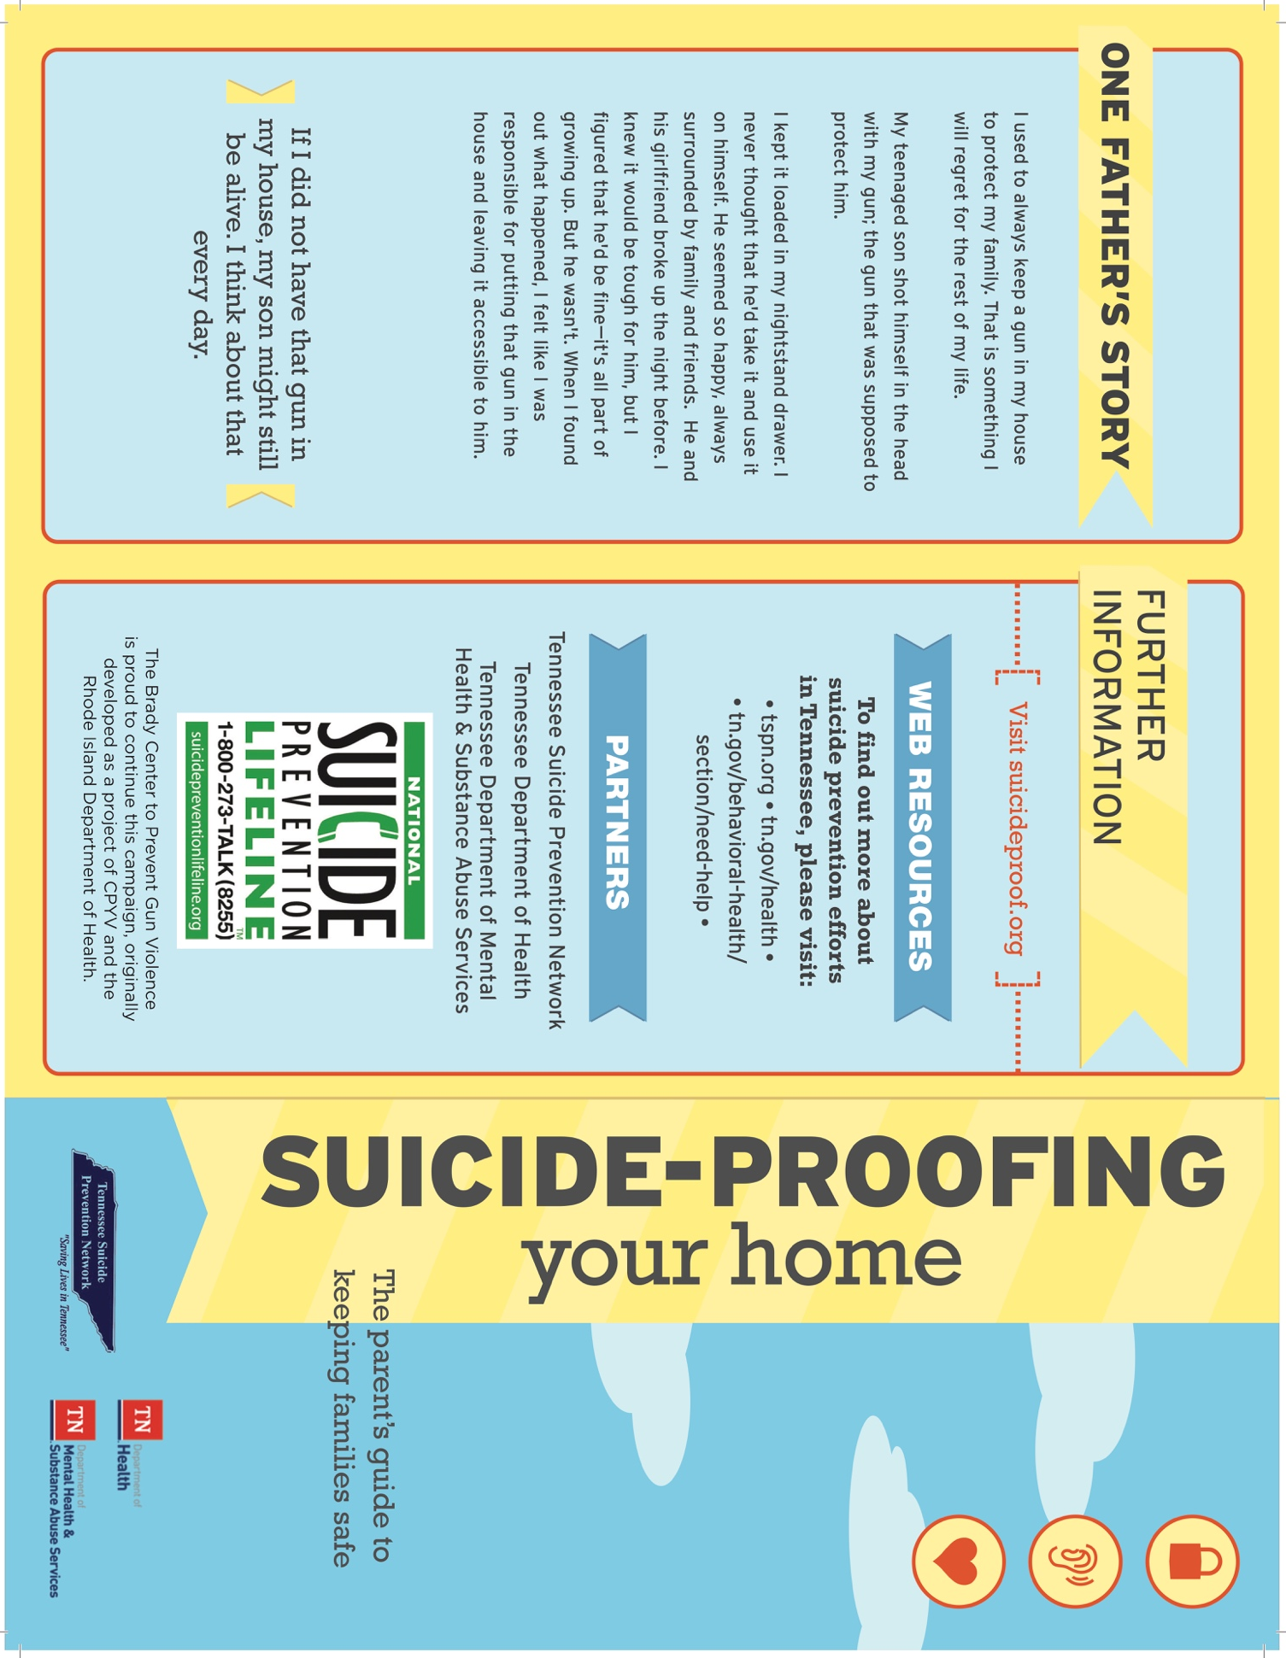
Form H

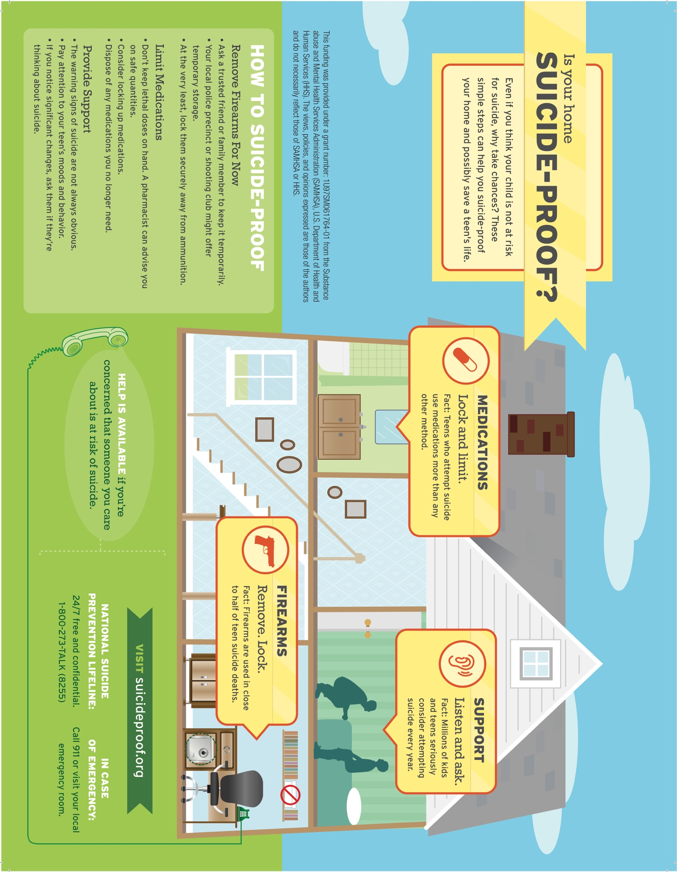
*Retrieved from: http://tspn.org/wp-content/uploads/2016/02/SPYH.pdf
Form I
RELEASE OF INFORMATION TO FACULTY/STAFF

In anticipation of my child’s return to school, I _______________________________________,
(Printed Name of Parent/Guardian)

hereby give my consent for information regarding ___________________________________’s
(Printed Name of student)

current condition to be shared with faculty and staff on a need-to-know basis.

________________________________________________ __________________
(Parent/Guardian Signature) (Date)

Form J
FOLLOW-UP MEETING
Student’s Name: ______________________________ Date of Meeting: _________________
Parent/Guardian in Attendance: _________________________________________________
School Personnel in Attendance: _________________________________________________
Student’s status including any current mental health treatment or counseling: ______________________________________________________________________________
Offer the parent/guardian the Consent to Contact form, if not already done (document parent’s response): ______________________________________________________________________________ ______________________________________________________________________________
Recommendations by behavioral health professional: ______________________________________________________________________________ ______________________________________________________________________________ ______________________________________________________________________________ Strategies for handling make-up work or academic accommodations: ____________________________________________________________________________________________________________________________________________________________
Assistance for parents/guardians: ____________________________________________________________________________________________________________________________________________________________
Referrals to community based teams or service providers: ____________________________________________________________________________________________________________________________________________________________
Future meeting dates (if needed): __________________________________________________
Action plans: __________________________________________________________________
______________________________________________________________________________
Bibliography

The Columbia Lighthouse Project (2017). “The Columbia Scale (C-SSRS): About the Scale.” Available URL: http://cssrs.columbia.edu/the-columbia-scale-c-ssrs/about-the-scale

DiCara, C., O'Halloran, S., Williams, L., and Canty-Brooks, C. (2009). Youth suicide prevention, intervention, and postvention guidelines. Augusta, ME: Maine Youth Suicide Prevention Program. Available URL: www.maine.gov/suicide/docs/Guidelines%2010-2009--w%20discl.pdf.

Stanley, B. & Brown, G.K. (2011). Safety planning intervention: A brief intervention to mitigate suicide risk. Cognitive and Behavioral Practice. 19, 256–264.
Substance Abuse and Mental Health Services Administration (2012). Preventing Suicide: A Toolkit for High Schools. HHS Publication No. SMA-12-4669. Rockville, MD: Center for Mental Health Services, Substance Abuse and Mental Health Services Administration.
Substance Abuse and Mental Health Services Administration. Behavioral Health Treatment Services Locator. Available URL: https://findtreatment.samhsa.gov/
Suicide Prevention Resource Center (2009). “CALM: Counseling on Access to Lethal Means.” Available URL: http://www.sprc.org/resources-programs/calm-counseling-access-lethal-means-0
The Trevor Project. Model School District Policy on Suicide Prevention: Model Language, Commentary, and Resources. Available URL: http://www.thetrevorproject.org/pages/modelschoolpolicy
Tennessee Department of Education (2016). Model Suicide Prevention Policy & Student Suicide Resources. Nashville, TN: Tennessee Department of Education.
Tennessee Suicide Prevention Network (2005). Suicide Postvention Guidelines: Suggestions for Dealing with the Aftermath of Suicide in the Schools. Nashville, TN: Tennessee Suicide Prevention Network. Available URL: http://tinyurl.com/tspn-aas-postvention
Tennessee Suicide Prevention Network (2016). Suicide-Proofing Your Home: The Parent's Guide to Keeping Families Safe. Nashville, TN: Tennessee Suicide Prevention Network. Available URL: http://tspn.org/wp-content/uploads/2016/02/SPYH.pdf

TSPN would like to thank Maury County Public Schools as serving as the pilot for the development and implementation of this document. Special thanks to Dr. Robb Killen, Supervisor of Counseling and Mental Health for Maury County Public School and the staff and leadership staff at Youth Villages, Mental Health Cooperative, Inc, Helen Ross McNabb Center, the Tennessee Department of Education Project TN AWARE leadership, and the Tennessee Department of Mental Health and Substance Abuse. TSPN would also like to thank David N. Miller, PhD, Past-President, American Association of Suicidology (AAS), Associate Professor of School Psychology Department of Educational & Counseling Psychology University at Albany, State University of New York; Sue Eastgard, MSW, former founder of Youth Suicide Prevention Program of Washington State and Past-President, American Association of Suicidology (AAS); and James J. Mazza, PhD, Professor, School Psychology Program at the University of Washington, Past-President, American Association of Suicidology.
www.TSPN.org

