It Starts at the Top: School Leadership that Moves the Needle for ELs
Friday, September 19, 2025

Effective Professional Development  What elements of effective professional development are included in this demonstration? | 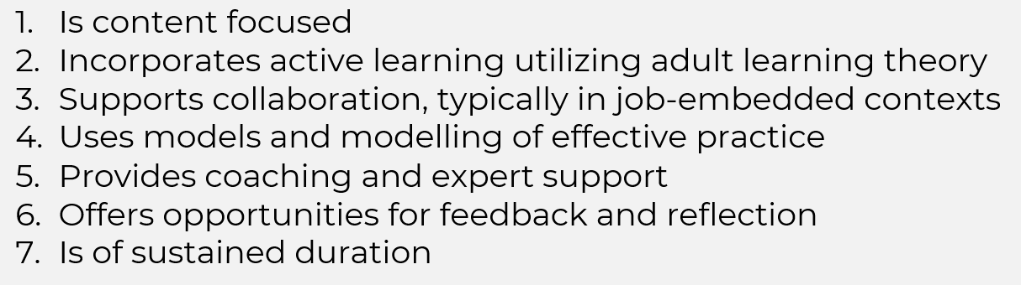
Professional Development Demonstration

Worked Example

Word Sort

Reflection

How did this demonstration incorporate elements of effective professional learning for adults?

As a leader, how could you incorporate this in your schools?

Worked Example
