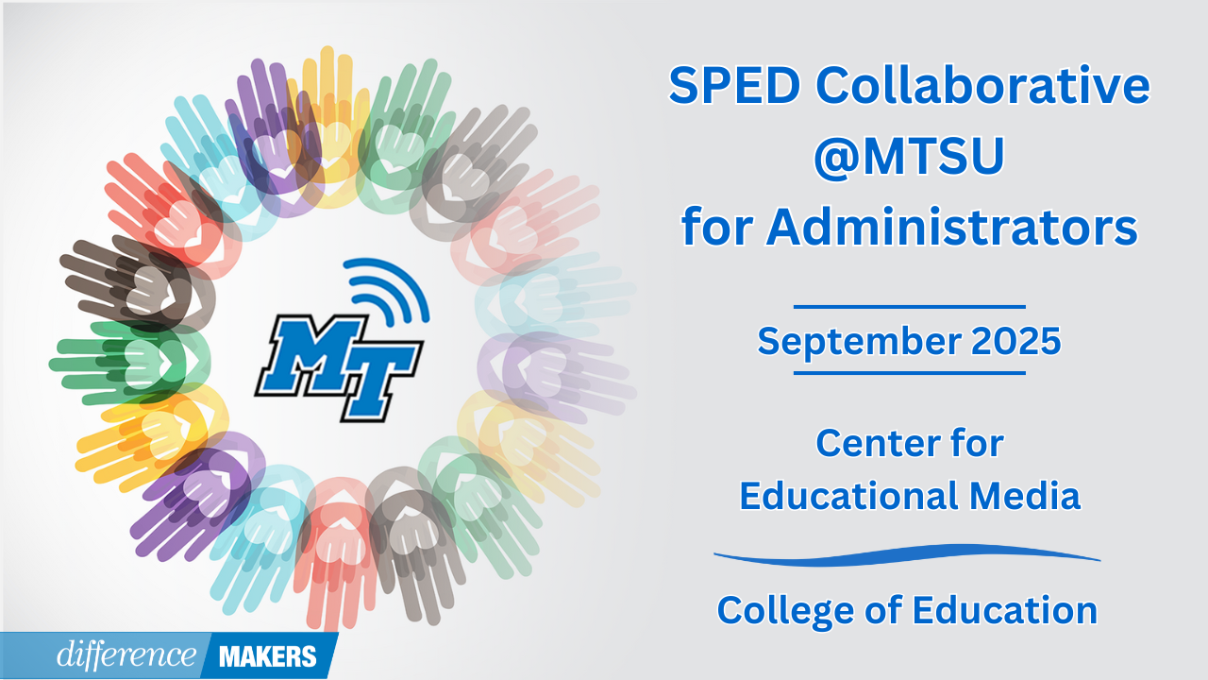

**SPED Collaborative @MTSU for Administrators**

**Onsite Conference**

**September 26, 2025**

**8:30am- 8:45am Welcome/Introductions**

* Jenny Marsh, Manager, CEM Professional Development Center, MTSU
* Dr. Laura Clark, Director, Center for Educational Media, MTSU
* Dr. Neporcha Cone, Dean College of Education, MTSU

**8:45am-10:00am (Session 1) Working Together for Impact: The Administrative Team's Role in Special Education Success**

* Dr. Charles Farmer, Principal, Freedom Middle School, Franklin Special District
* Dr. Lauren Bauer, Assistant Principal, Freedom Middle School, Franklin Special District
* Adam Demonbreun, Asst Principal/Athletics Director, Freedom Middle School, Franklin Special District

**10:00am-10:15am Break**

**10:15am-11:30am (Session 2) Working Together for Impact: The Administrative Team's Role in Special Education Success**

* Dr. Charles Farmer, Principal, Freedom Middle School, Franklin Special District
* Dr. Lauren Bauer, Assistant Principal, Freedom Middle School, Franklin Special District
* Adam Demonbreun, Asst Principal/Athletics Director, Freedom Middle School, Franklin Special District
* Q&A Facilitated by Dr. Laura Clark

**11:30am-12:45pm Networking Lunch**



**SPED Collaborative @MTSU for Administrators**

**Onsite Conference**

**September 26, 2025**

**12:45-12:50pm Afternoon Welcome/ Back in Seats**

**12:50-2:05pm (Session 3) The Building Leader’s Role as the Special Education LEA Representative**

* Susan Usery, Senior Director of Special Education Programs, TDOE
* Tate Ball, Associate Counsel for Special Education, TDOE
* Q&A Facilitated by Dr. Laura Clark

**2:05pm-2:20pm Break**

**2:20pm-3:35pm (Session 4) Support Your Teachers: Effects of a Rigorous and Supportive Coaching Cycle**

* Joshua Reese, Ed.S., Special Education Supervisor, Loudon County Schools
* Jessica Williams, Ed.S., Special Education Supervisor, Loudon County Schools
* Q&A Facilitated by Dr. Laura Clark

**3:35pm-3:45 Close/Certificates**

* Dr. Laura Clark, Director, Center for Educational Media, MTSU