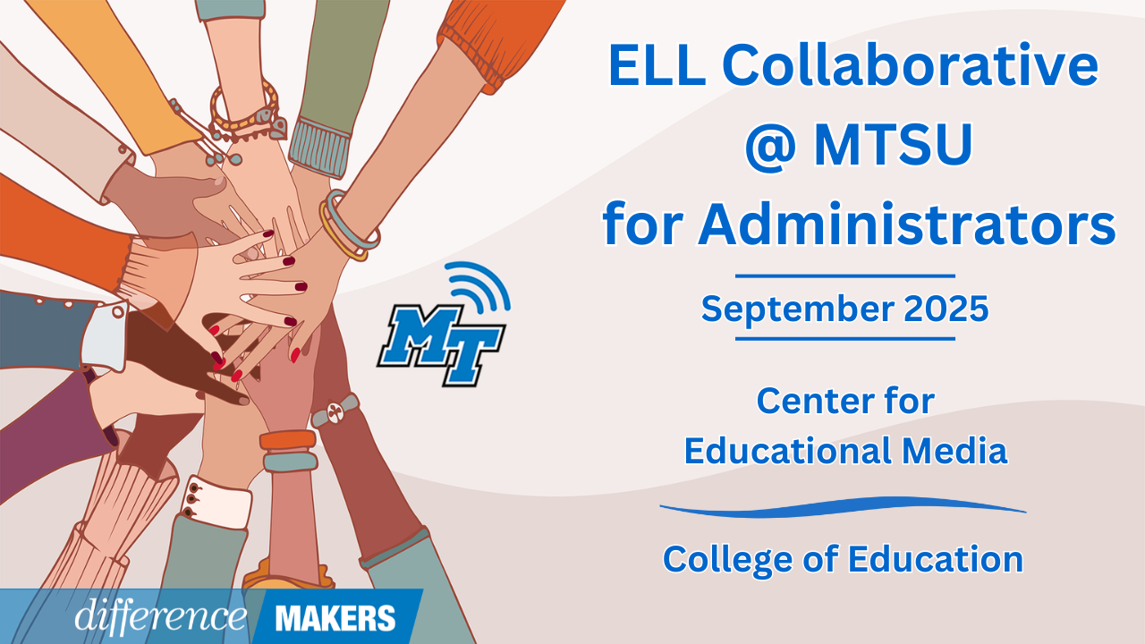  
**ELL Collaborative @ MTSU for Administrators**

**Onsite Conference**

**September 19, 2025**

**8:30am- 8:45am Welcome/Introductions**

* Jenny Marsh, Manager, CEM Professional Development Center, MTSU
* Dr. Laura Clark, Director, Center for Educational Media, MTSU
* Dr. Neporcha Cone, Dean College of Education, MTSU
* Dr. Janna Brown McClain, Asst. Professor, Elementary and Special Education, MTSU

**8:45am-10:15am Instructional Coherence and English Learners**

* Dr. Haley Richardson, Senior Manager of Intervention, TDOE

**Q&A Session**

* + Joann Runion, Senior Director of Student Support, TN Department of Education
  + Dr. Hannah Gribble, Title III and Migrant Education Program Grant Manager, TDOE
  + Raven Cleveland, Manager of English Learner Strategy, TN Department of Education
  + Q&A Facilitated by Dr. Laura Clark and Dr. Janna Brown McClain

**10:15-10:30 Break**

**10:30-12:00 It Starts at the Top: School Leadership that Moves the Needle for ELs**

* Erica Rayburn, High School English as New Language Content Lead, Hamilton County Schools
* Bleshette Coulter, Secondary Math Content Lead, Missionary Ridge Learning Community, Hamilton County Schools
* Q&A Facilitated by Dr. Laura Clark and Dr. Janna Brown McClain

**12:00-1:15 Networking Lunch**



**ELL Collaborative @ MTSU for Administrators**

**Onsite Conference**

**September 19, 2025**

**1:15-1:20pm Afternoon Welcome/ Back in Seats**

**1:20-2:50pm (Session 3) Beyond Pull-Outs: Building Sustainable ESL-Classroom Collaboration Models**

* Malcom Martin, Assistant Principal, Cartwright Elementary, Bedford County Schools
* Q&A Facilitated by Dr. Laura Clark and Dr. Janna Brown McClain

**2:50-3:05Close/Certificates**

* Dr. Laura Clark, Director, Center for Educational Media, MTSU