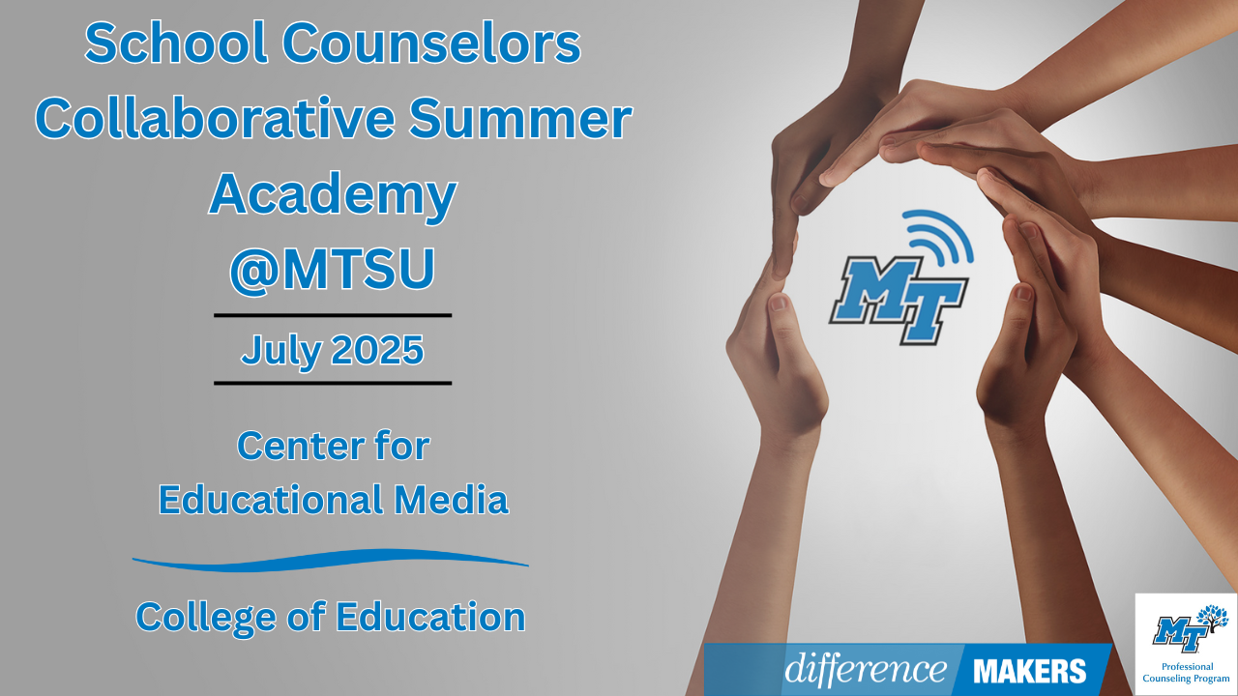**School Counselors Collaborative Summer Academy**

**Onsite Conference**

**July 8, 2025**

**8:30am- 8:45am Welcome/Introductions**

* Dr. Laura Clark, Director, Center for Educational Media, MTSU
* Dr. Neporcha Cone, Dean- College of Education, MTSU

**8:45am-10:00am (Session 1)** **TDOE UPDATES**

* Jaime Grammer, School Counseling Manager, TN Department of Education
* Brittany Slagle, Manager of Individualized Advising, TN Department of Education
* Sheri Smith, School Counselor Consultant, Project RAISE, TN Department of Education
* Q&A Facilitated by Dr. Laura Clark

**10:00-10:15 Break**

**10:15-11:30(Session 2) Elementary School Counseling Strategies for Individual and Group Support**

* Kushana Collier, School Counselor, Metro Nashville Public Schools
* Q&A Facilitated by Dr. Laura Clark

**11:30-12:45 Networking Lunch**

**School Counselors Collaborative Summer Academy**

**Onsite Conference**

**July 8, 2025**

**12:45-12:50pm Afternoon Welcome/ Back in Seats**

* Dr. Laura Clark, Director, Center for Educational Media, MTSU
* William Feck, EdS, LPC/MHSP, NCC, CSAT, Professional Counseling Program, MTSU

**12:50-2:05pm (Session 3) Empowering Student Success Through Executive Function Support**

* Laura Filtness, M. Ed., School Counselor, Knox County Schools
* Q&A Facilitated by Dr. Laura Clark

**2:05-2:20 Break**

**2:20-3:35 (Session 4) R-E-S-P-E-C-T: Classroom Contracts & Community Building for Proactive Classroom Management**

* Angela Ruzicka, M.Ed., School Counselor, Blackman Elementary School
* Q&A Facilitated by Dr. Laura Clark

**3:35-4:00pm Close/Certificates**

* Dr. Laura Clark, Director, Center for Educational Media, MTSU