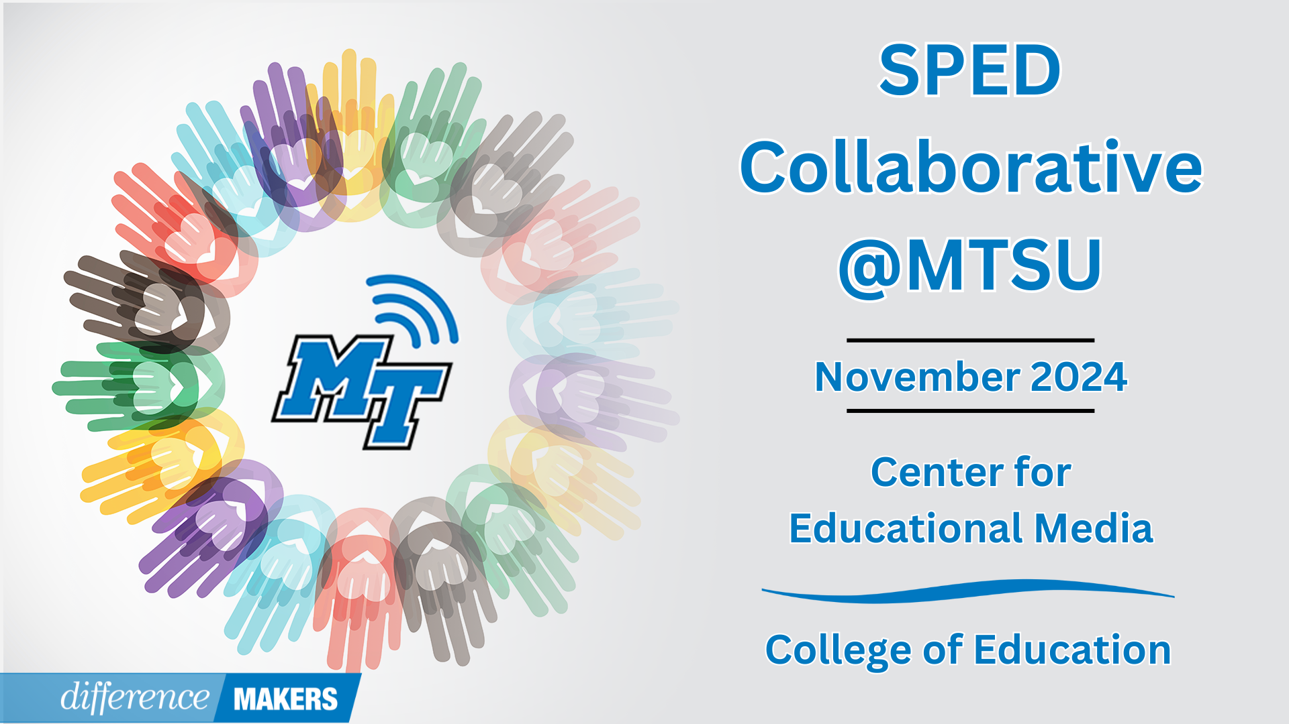

**SPED Collaborative Teacher Day**

**Hybrid Conference**

**November 12, 2024**

**9:00- 9:15am Welcome/Introductions**

* Dr. Laura Clark, Director, Center for Educational Media, MTSU
* Dr. Alicia Pence, President TN-CEC

**9:15-10:30 (Session 1)** **It’s Not US vs THEM; It’s ALL Special Ed!**

* Crista Crittenden, MS CCC-SLP, Preschool Speech Language Pathologist, Tullahoma City Schools
* Q&A Facilitated by Dr. Laura Clark

**10:30-10:45 Break**

**10:45-11:15(Session 2) TDOE Updates**

* Susan Usery, M.S.; Senior Director of Special Education Programs, TDOE
* Q&A Facilitated by Dr. Laura Clark

**11:15-11:30-Break**

**11:30-11:35** **Greeting from Dean**

* Dr. Neporcha Cone, Dean College of Education, MTSU

**11:35-1:05(Session 3) Strengthening Collaborative Partnerships Between General and Special Education in Middle and High School Settings**

* Kimberly Hale, PhD LBA BCBA, Board Certified Behavior Analyst, Macon County Schools
* Stacy Williamson, IEP Coordinator, Macon County Schools
* Q&A Facilitated by Dr. Laura Clark

**1:05-1:20Close/Certificates**

* Dr. Laura Clark, Center for Educational Media, MTSU