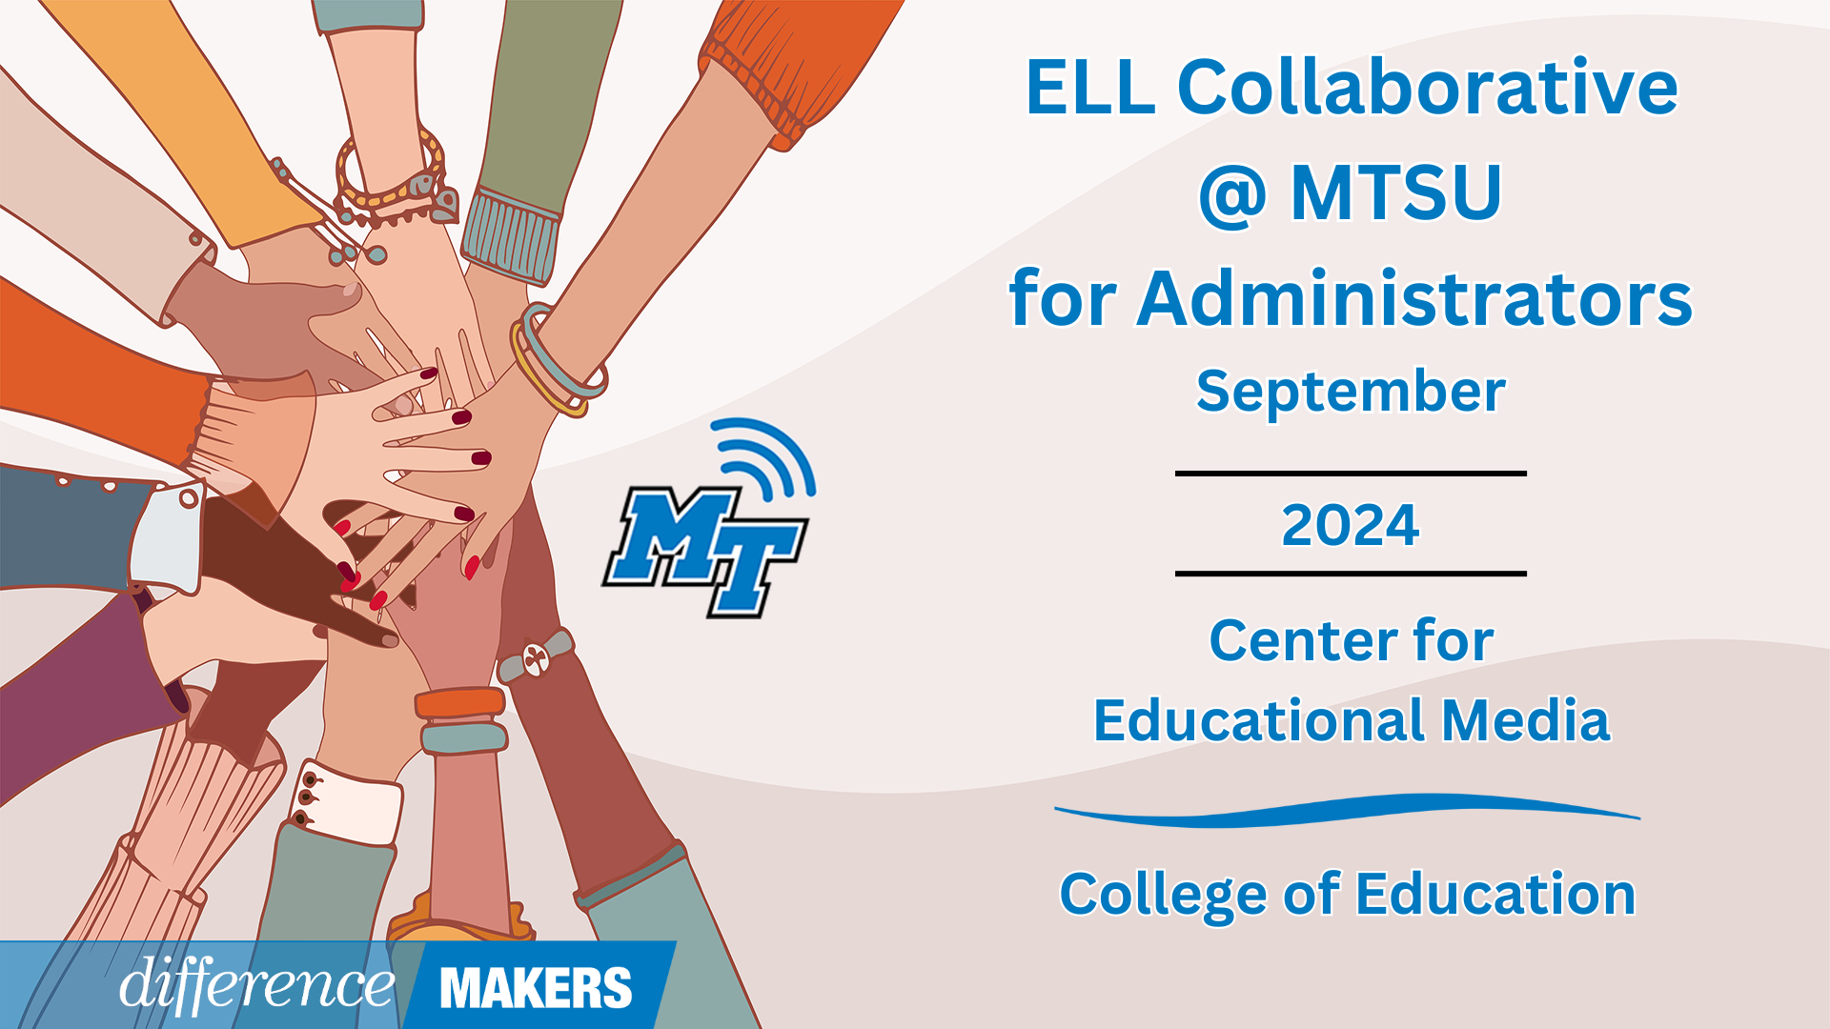

**ELL Collaborative @ MTSU for Administrators**

**Onsite Conference**

**September 20, 2024**

**8:30am- 8:45am Welcome/Introductions**

* Dr. Laura Clark, Director, Center for Educational Media, MTSU
* Dr. Neporcha Cone, Dean College of Education, MTSU
* Dr. Janna Brown McClain, Asst. Professor, Elementary and Special Education, MTSU

**8:45am-10:00am Administrators Supporting ELPA21 in Schools**

* Raven Cleveland, Senior Coordinator of English Learners, TDOE
* Joann Runion, Senior Director of Student Support, TDOE
* Q&A Facilitated by Dr. Laura Clark and Dr. Janna Brown McClain

**10:00-10:15 Break**

**10:15-11:30 Administrators Supporting ELPA21 in Schools (continued)**

* Raven Cleveland, Senior Coordinator of English Learners, TDOE
* Dr. Haley Richardson, Senior Manager of Intervention, TDOE
* Q&A Facilitated by Dr. Laura Clark and Dr. Janna Brown McClain

**11:30-12:45 Networking Lunch**



**ELL Collaborative @ MTSU for Administrators**

**Onsite Conference**

**September 20, 2024**

**12:45-12:50pm Afternoon Welcome/ Back in Seats**

* **12:50-2:05pm (Session 3) Navigating Challenges: Ensuring Achievement of EL’s**
* Dr. Kevin Stacy, EL Coordinator, Clarksville Montgomery
* Q&A Facilitated by Dr. Laura Clark and Dr. Janna Brown McClain

**2:05-2:20 Break**

**2:20-3:35 (Session 4) Championing Tennessee Voices: Writing Across the Curriculum**

* Donna M. Neary, Ed.S., English New Language Specialist, Hamilton County Schools
* Q&A Facilitated by Dr. Laura Clark and Dr. Janna Brown McClain

**3:35-3:50 Close/Certificates**

* Dr. Laura Clark, Director, Center for Educational Media, MTSU