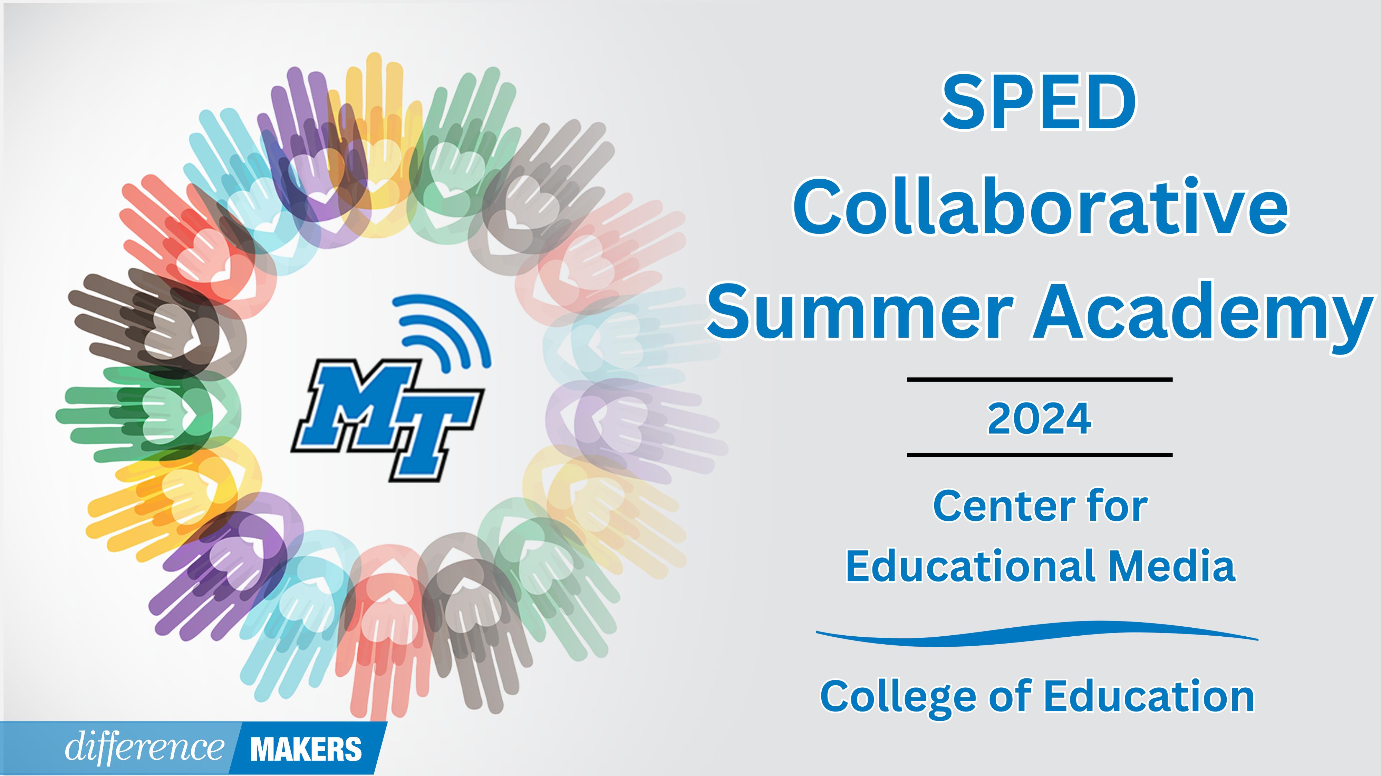

**SPED Collaborative Summer Academy**

**Onsite Conference**

**July 16, 2024**

**8:30am- 8:45am Welcome/Introductions**

* Dr. Laura Clark, Director, Center for Educational Media, MTSU
* Dr. Neporcha Cone, Dean College of Education, MTSU

**8:45am-10:00am (Session 1)** **Classroom Behavior: How Did We Get Here?**

* Dr. Larry J. Crismon II, Behavior Specialist Rutherford County Schools
* Katie Fann, M.Ed., LBA, BCBA Rutherford County Schools

**10:00-10:15 Break**

**10:15-11:30(Session 2) Classroom Behavior: How Did We Get Here? (cont.)**

* Dr. Larry J. Crismon II, Behavior Specialist Rutherford County Schools
* Katie Fann, M.Ed., LBA, BCBA Rutherford County Schools
* Q&A Facilitated by Dr. Laura Clark

**11:30-12:45 Lunch**



**SPED Collaborative Summer Academy**

**Onsite Conference**

**July 16, 2024**

**12:45-12:50pm Afternoon Welcome/ Back in Seats**

* MTSU Center for the Study and Treatment of Dyslexia-Updates
  + Dr. Melinda Hirschmann

**12:50-2:05pm (Session 3) Implicit Bias in the IEP Process**

* Taylor Biondi, Ed.D., Metro Nashville Public Schools
* Chris Flor, M. Ed., Metro Nashville Public Schools
* Q&A Facilitated by Dr. Laura Clark

**2:05-2:20 Break**

**2:20-3:35 (Session 4) What the TN Department of Education is Doing to Support Educators and Schools**

* Susan Usery, Senior Director of Special Education Programs, TDOE
* Dr. Haley Richardson, Senior Manager of Intervention, TDOE
* Dr. April Ebbinger, Director of Psychological and Behavioral Services, TDOE
* Allyson Collins, Senior Manager of Complex Behavior Services, TDOE
* Jamie Seek, Manager of Speech-Language & Related Services, TDOE
* Alison Gauld, Senior Manager of Professional Learning and Low Incidence, TDOE
* Q&A Facilitated by Dr. Laura Clark

**3:35-3:40 CEC Updates**

* Dr. Alicia Pence, President TN-CEC

**3:40-3:50 Close/Certificates**

* Dr. Laura Clark, Director, Center for Educational Media, MTSU