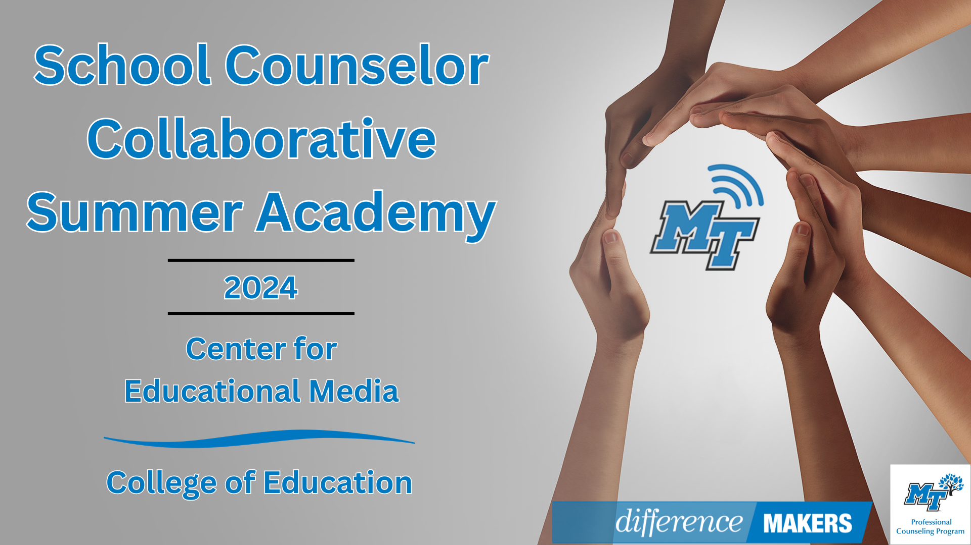

**School Counselors Collaborative Summer Academy**

**Onsite Conference**

**July 9, 2024**

**8:30am- 8:45am Welcome/Introductions**

* Dr. Laura Clark, Director, Center for Educational Media, MTSU
* Dr. Tiffany Wilson, Associate Professor, Professional Counseling Program, MTSU
* Dr. Neporcha Cone, Dean- College of Education, MTSU

**8:45am-10:00am (Session 1)** **Creating Systems for Connection in School Counseling**

* Sara Puffer,Professional School Counselor, McFadden School of Excellence
* Q&A Facilitated by Dr. Laura Clark and Dr. Tiffany Wilson

**10:00-10:15 Break**

**10:15-11:30(Session 2) When Trauma Impedes Student Learning: Exploring Ways to Support Students’ Social and Emotional Wellbeing as They Navigate Academic Success**

* Jazmin Byrd, Content Creator & Author, Elementary School Counselor
* Q&A Facilitated by Dr. Laura Clark and Dr. Dr. Tiffany Wilson

**11:30-12:45 Networking Lunch**



**School Counselors Collaborative Summer Academy**

**Onsite Conference**

**July 9, 2024**

**12:45-12:50pm Afternoon Welcome/ Back in Seats**

**12:50-2:05pm (Session 3) Brick By Brick: Using Legos in your Counseling Program**

* Ally Evans, M.A; Professional School Counselor K-4, Putnam County
* Q&A Facilitated by Dr. Laura Clark and Dr. Tiffany Wilson

**2:05-2:20 Break**

**2:20-3:35 (Session 4) Planting the Seeds**

* Jaime Grammer, School Counseling Manager, TN Department of Education
* Q&A Facilitated by Dr. Laura Clark and Dr. Tiffany Wilson

**3:35-3:45 TSCA Updates**

* Dr. Laura Clark
* Dr. Katie Wood, TN Tech University, TSCA Board Member
* Jacquelyn Patterson, TSCA School Counselor of the Year, Rockvale Middle School

**3:45-4:00pm Close/Certificates**

* Dr. Laura Clark, Director, Center for Educational Media, MTSU