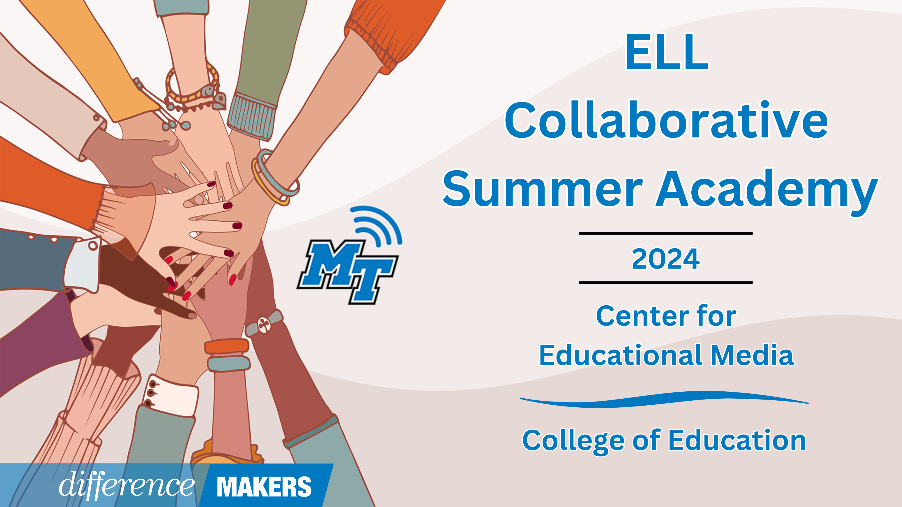

**ELL Collaborative Summer Academy**

**Onsite Conference**

**July 11, 2024**

**8:30am- 8:45am Welcome/Introductions**

* Dr. Laura Clark, Director, Center for Educational Media, MTSU
* Dr. Neporcha Cone, Dean College of Education, MTSU

**8:45am-10:00am (Session 1)** **Reach for the Stars: How Writing Can Boost All Areas of English Language Development**

* Sunita Watson, ESL Teacher, Barfield Elementary School
* Q&A Facilitated by Dr. Laura Clark

**10:00-10:15 Break**

**10:15-11:30(Session 2) The Phonics Project in Williamson County Schools ESL Program: Building the /pleɪn/ as we /flaɪ/**

* Joseph Whinery, Williamson County Schools ESL Program Supervisor
* Ann Matanakilagi, Williamson County Schools ESL Specialist
* Q&A Facilitated by Dr. Laura Clark

**11:30-12:45 Lunch**



**ELL Collaborative Summer Academy**

**Onsite Conference**

**July 11, 2024**

**12:45-12:50pm Afternoon Welcome/ Back in Seats**

**12:50-2:05pm (Session 3) ELPA21 In Tennessee Parts 1 and 2**

Part I: The 5 Wh-s of ELPA21 (Updates of Rule/Policy) 30 min

Part II: ELPA21 and Tennessee State Standards (How-to Crosswalk) 45 min

* Raven Cleveland, Senior Coordinator of English Learners, TDOE
* Hannah Gribble, Title III and Migrant Education Program Grant Manager, TDOE
* Joann Runion, Senior Director of Student Support, TDOE

**2:05-2:20pm Break**

**2:20-3:50pm (continued Session 3) ELPA21 In Tennessee Parts 3 and 4**

Part III: ELPA21 and the ILP (Changes & Goal Setting) 45 min

Part IV: Moderated Q&A 45 min

* Raven Cleveland, Senior Coordinator of English Learners, TDOE
* Dr. Hannah Gribble, Title III and Migrant Education Program Grant Manager, TDOE
* Joann Runion, Senior Director of Student Support, TDOE
* Q&A Facilitated by Dr. Laura Clark

**3:50-4:00 Close/Certificates**

* Dr. Laura Clark, Director, Center for Educational Media, MTSU